A guide to Class Charts
Rewards and Sanctions at Monkseaton High School

At Monkseaton High School we aim to promote excellence and respect for all through our ethos of Equality, Opportunity, Inclusion & Achievement.

We are committed to ensuring our students develop academically, socially, and emotionally into young adults who are equipped with the skills to be successful in the future.

Our culture is built on the concept of RESPECT, a positive attribute. This positivity is reflected in the importance that the school places on the rewarding of students. The RESPECT code outlines our values and expectations at Monkseaton High School.

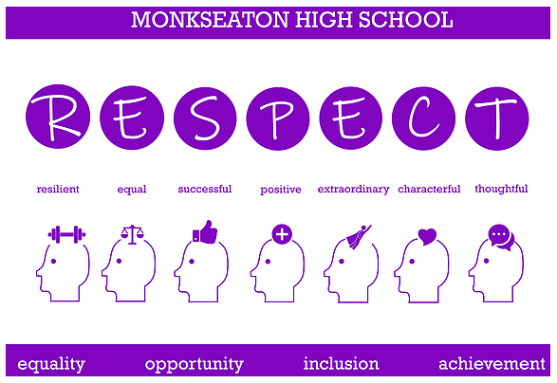

Class Charts:
At MHS we use Class Charts to acknowledge and praise positive behaviour and actions demonstrating the RESPECT values. Through our Class Charts system, there are a range of opportunities available to staff to reward students. Staff will record students’ behaviour and achievements through Class Charts.

Rewards:

- Rewards are linked to the RESPECT values which supports our school values and ethos
- RESPECT points may be given out by members of staff for a range of reasons and are shared and celebrated in a number of ways
- All points are recorded on Class Charts.

Students have the opportunity to be rewarded in every lesson of the day. Staff will actively be looking for those students who are displaying the learning behaviours which meet our high expectations and RESPECT values. They will earn a RESPECT point worth one point.

In addition, staff can award students a Postcard or Star Student, both of which are worth five points, and are given for exceptional work. Students can also be rewarded by their form tutor for embodying our RESPECT code.

As part of our drive to create well-rounded students who are ready for either the next step in their education or the world of work, we also honour students for:

- Attending intervention sessions to improve a skill, for example reading
- Demonstrating RESPECT outside of the classroom
- Participating in an extra-curricular club or event
- Reading independently

Students and their parents/carers can all access the Class Charts system to track the RESPECT points being given.

Celebration and Recognition
As well as celebrating the number of positive RESPECT points earned, the school works on a ratio system comparing positive to negative points. This approach ensures all students are considered on an equal playing field. The school uses a banding of Gold (100% positive); Silver (97% positive); Bronze (95% positive) and celebrates these achievements in range of ways, including:

Weekly

- Acknowledge those students who are in the Gold, Silver and Bronze RESPECT point bands each week during assemblies/tutorials
- Phone home with positive news for students in each tutor group

Fortnightly
Invite selected students who have achieved 100% positive ratio across each two-week period to attend a ‘Hot Chocolate Friday’ event with senior staff

Termly
The school will arrange celebratory events appropriate to each RESPECT point band, for example:

- Gold – an afternoon off timetable to have pizza/games afternoon

Yearly
The school will arrange celebratory events appropriate to each RESPECT point band, for example:

- Gold – an afternoon off timetable to visit a local cinema/stables/city;
- Silver – an afternoon off timetable to attend a film screening in school/enjoy an afternoon of pampering/take part in an assault course with the fusiliers;
- Bronze – a lesson off timetable to have pizza/game of dodgeball/sports session/games afternoon

Class Charts Shop

In addition, students will have the opportunity to cash in points for rewards throughout the year. Some examples of items students can cash points in for are:
- Amazon Voucher
- Lunch queue jumper
- Pens
- Scientific calculator
- Highlighter set
- Revision guides

Class Charts – Behaviour and Sanctions:

Students are encouraged to adopt behaviours that support learning and promote positive relationships. Even when encouraged to make the right choice, some students will sometimes make choices that are detrimental to their own learning or that of others. A series of strategies will then be used to bring about changes to these behaviours. The aim of these strategies is to encourage students to understand our expectations and re-engage with learning.

The RESPECT Code is designed to give students choices and to support learning by tackling and dealing with low-level disruptive behaviour; that is behaviour that undermines the student’s own learning or that of others. The system is designed to improve consistency across the school and give students the opportunity to reflect on their actions and change their behaviour. A number of phases are applied to support this approach:

Expectation reminder – initial reminder about expectations (this is a personal reminder to an individual student)
P1 | Verbal warning
P2 | Final verbal warning (before any sanction). This is recorded and logged on ClassCharts
P3 | Call back issued (10-minute detention that day)
P4 | On called and removed from classroom (20-minute detention that day)
Whole School Detention – Mon/Wed/Fri
A whole school detention will be issued when a student has failed to turn up for a P3/4 detention. You will be notified by text and the detention will last for 45 minutes.

Type of behaviour that could result in a negative point on Class Charts*:
- Arriving late to school
- Arriving late to a lesson
- Not being equipped for lessons e.g. not having a pen
- Not completing homework

Type of behaviour that negatively affect learning and will result in a P1-3 sanction* (these will incur a negative point on Class Charts):
- Distracting others
- Persistently talking
- Talking when the teacher is talking
- Not following teacher instructions
- Leaving seat/classroom without permission
- Poor work completion
- Inappropriate language

Types of behaviour that may result in a P4* (and possible further investigation) (these will incur a negative point on Class Charts):
- Inappropriate comments towards other students
- Racist/homophobic comments
- Defiance/rudeness towards staff
- Persistent refusal to follow instructions

*list is not exhaustive
Please see our full student behaviour policy on our website https://www.monkseaton.org.uk/policies-documents for further details.

Parent/Carer support:
Parents/Carers are asked to support the school with our positive culture and our high expectations. We ask parents to work with us in support of their child’s learning and to celebrate and praise achievement and hard work. Parents/Carers also play an important part in their children being responsible for their own behaviour in school. Ensuring that their child is at school on time, appropriately dressed, rested, and equipped, will encourage them to adhere to school rules and procedures.

We hope that Class Charts provides parents/carers with information to do this effectively so that together we can ensure your child is able to achieve wonderful things.

If you need help to access your Class Charts account please contact Kerry.davison@monkseaton.org.uk

