The Science Department

Mrs Watts Mr Dear Mrs Jones Mrs Purdy Mr Cairns Mrs Brogden

Guess which member of staff:

- is a drummer

- is originally from Canada

- has a dog called ‘Hugo’

- once met Noel Gallagher from Oasis

- is a season ticket holder for Newcastle United

- has discovered new hobbies, of cycling and bird watching, since lockdown

You

Task 1 - Now introduce yourself to us and to find out about chemistry linked to your birthday.

What to do:

Go to this website: https://edu.rsc.org/resources/collections/on-this-day-in-chemistry

Click on your birthday and then fill in the form to tell us why your birthday is important in chemistry.

Hints:
- Fill in the form in your own words
- If there is a word you don’t understand, ask someone for help, or look it up in a dictionary or on the internet
- You can draw a picture or find one on the internet.
Why is my birthday important in chemistry?

Name: My birthday is on:

This is what happened:

Here is a picture of my chemist, or the event that happened:

The Scientific Method
Introduction

Science is ultimately having a child’s mindset. Endlessly questioning how and why things are the way they are. ‘Why do rainbows happen?’, ‘Why is the sky blue?’, ‘Why do scissors come in packaging that you need scissors to open?’; we then research/observe to try and understand these questions and come up with possible answers (we call these hypotheses).

For example, I can observe that rainbows only occur when it is both raining and the sun is out, so I think that it must be due to some interaction between the water and rain. However, this would not be a hypothesis as it is too vague, I’d have to be specific and state that I think it could be what angle the light is to a rain drop.

I can then do an experiment to test this. I collect my results and form a conclusion (then at higher levels communicate these findings to others – in the hope that they can do the experiment and confirm my findings). This is the scientific method.
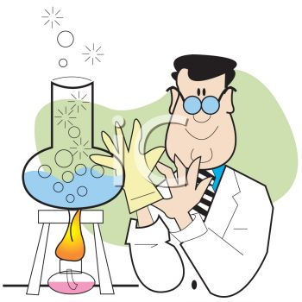

The Steps of the Scientific Method

- Problem/Question
- Observation/Research
- Formulate a Hypothesis
- Experiment/ Test
- Collect and Analyze Results
- Conclusion
- Communicate the Results

Terminology

Before we go any further there are a few terms you will need to be familiar with:

- HYPOTHESIS: The hypothesis is an educated guess about the relationship between the independent and dependent variables.

- INDEPENDENT VARIABLE: is a factor that’s intentionally altered by the experimenter.

- DEPENDENT VARIABLE: is the factor that may change as a result of changes made in the independent variable and so is measured during the experiment

- CONTROL VARIABLES: The constants in an experiment are all the factors that the experimenter attempts to keep the same.

A good way to remember the different variables are CID and SAM:

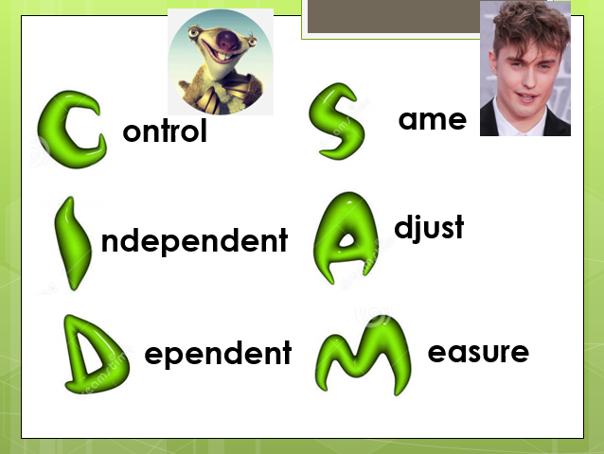

- CONTROL GROUP: In a scientific experiment, the control is the group that serves as the standard of comparison. The control group may be a “no treatment" or an “experimenter selected” group.

The control group is exposed to the same conditions as the experimental group, except for the variable being tested.

E.g. Suppose a researcher feeds an experimental artificial sweetener to sixty laboratory rats and observes that ten of them subsequently die.

The underlying cause of death could be the sweetener itself or something unrelated. For instance, perhaps the rats were simply not supplied with enough food or water, or the water was contaminated and undrinkable, etc.

Eliminating each of these possible explanations individually would be time-consuming and difficult. Instead, the researcher can use an experimental control, separating the rats into two groups: one group that receives the sweetener and one that does not.

The two groups are kept in otherwise identical conditions, and both groups are observed in the same ways. Now, any difference in morbidity between the two groups can be ascribed to the sweetener itself—and no other factor—with much greater confidence.
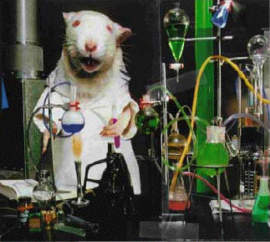

Task 2 – To help you get used to these words (and others related to the scientific method) either complete the wordsearch or challenge yourself to complete the crossword
Choose the line tool from Insert > Shapes and draw lines across each word.
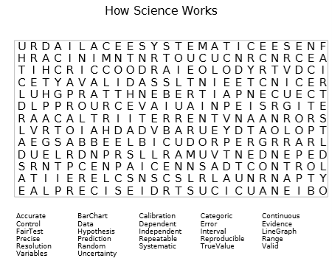

Task 3 – type the correct letter into each cell of the table

 |  |  |  |  |  |  | ¹
 |  |  |  |  |  |  |  |  | ²
 |  |  |  |  |  | ³
 | ⁴
 |  |  | ⁵ |  | ⁶
 |  |  |  |  |  |  |  |  |  |  |  | ⁷
 |  |  |  |  |  |  |  |  | ⁸
 | ⁹
 |  |  |  |  |  |  |  |  |  |  | ¹⁰
 | ¹¹ | ¹² |  |  |  | ¹³
 |  |  |  |  |  |  |  | ¹⁴
 |  |  |  |  |  |  |  |  |  |  |  |  |  |  |  |  |  |  | ¹⁵
 |  |  |  | ¹⁶
 |  |  |  |  |  |  |  |  |  | ¹⁷
 |  |  |  |  |  |  |  |  |  |  | ¹⁸
 |  |  |  |  |  |  |  |  |  |  |  |  |  |  | ¹⁹
 |  |  |  |  |  |  |  |  |  |  |  |  |  |  |  |  |  |  | ²⁰
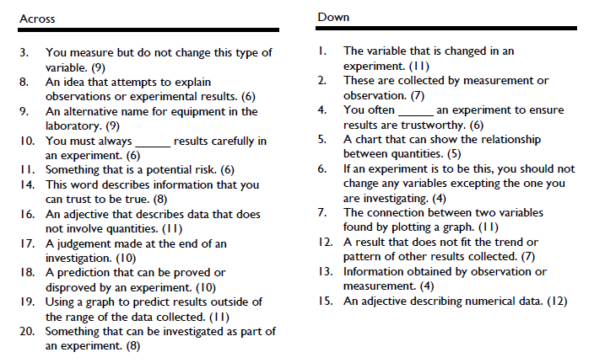

IV: | DV:

IV: | DV:
IV: | DV:

IV: | DV:

IV: | DV:

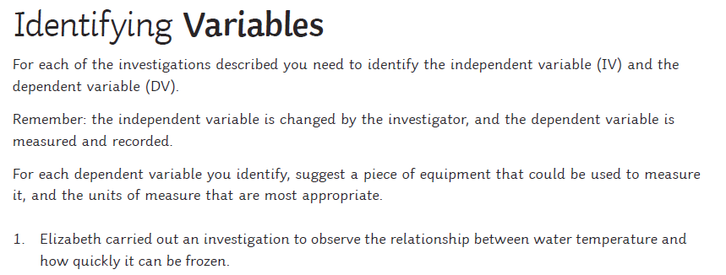

IV: | Equipment:
DV: | Units:

IV: | Equipment:
DV: | Units:

IV: | Equipment:
DV: | Units:

IV: | Equipment:
DV: | Units:

Task 4 - Remember we said a hypothesis is an educated guess about the relationship between the independent and dependent variables. For each of the experiments choose the correct hypothesis.

- A scientist has 12 plants. All the plants were the same kind and about the same size. He put three plants on a windowsill inside a room. He put another three plants in a cupboard without a light. He put another three more plants outside on the ground. He put his last three plants outside too, but covered them with paper bags that had holes punched in them for air. All the plants were given good soil and enough water. The plants on the window sill and the plants outside in the open grew well. The plants outside in the bags turned yellow and grew badly. The plants in the cupboard died. Which of the following is the best hypothesis based on the facts?

  - Green plants turn yellow due to disease
  - Green plants don’t live for very long
  - Green plants need light to grow
  - Green plants cannot grow inside
  - Green plants grow well in cupboards

- Louis Pasteur, a famous scientist who lived over 100 years ago, made an important hypothesis about a certain germ called bacteria. He noticed that bacteria grew quickly in open jars of liquid, like chicken soup. Bacteria also grew in jars of soup that were sealed tightly so that no air could get in. However, they didn’t grow in soup that was sealed tightly in a jar, then boiled and kept sealed after it cooled. What was Pasteur’s correct hypothesis?

  - Bacteria cannot grow in jars
  - Bacteria must have air to survive
  - Bacteria only grow in chicken soup
  - Bacteria can be killed by boiling
  - Bacteria can live in boiling liquids

Task 5 - Sugar or salt?
In this activity you will plan and do an investigation at home to answer this question: Can you dissolve more sugar, or more salt, in a glass of water?

My plan

Hypothesis:

Complete the table:

Variable | Will I change it or measure it or keep it the same?
Substance (sugar or salt)
Amount that dissolves
Volume of water
Temperature

Write down what you will do:

My results

Substance
Sugar
Salt

What I found out:

Extension: Simpson Experiments

Smithers thinks that a special juice will increase the productivity of workers. He creates two groups of 50 workers each and assigns each group the same task (in this case, they're supposed to staple a set of papers). Group A is given the special juice to drink while they work. Group B is not given the special juice. After an hour, Smithers counts how many stacks of papers each group has made. Group A made 1,587 stacks, Group B made 2,113 stacks. | Identify the:  1. Control Group  2. Independent Variable  3. Dependent Variable  4. What should Smithers' conclusion be?  5. How could this experiment be improved?
Homer notices that his shower is covered in a strange green slime. His friend Barney tells him that coconut juice will get rid of the green slime. Homer decides to check this this out by spraying half of the shower with coconut juice. He sprays the other half of the shower with water. After 3 days of "treatment" there is no change in the appearance of the green slime on either side of the shower. | 6. What was the initial observation?  Identify the-  7. Control Group  8. Independent Variable  9. Dependent Variable  10. What should Homer's conclusion be?
Bart believes that mice exposed to radiowaves will become extra strong (maybe he's been reading too much Radioactive Man). He decides to perform this experiment by placing 10 mice near a radio for 5 hours. He compared these 10 mice to another 10 mice that had not been exposed. His test consisted of a heavy block of wood that blocked the mouse food. He found that 8 out of 10 of the radiowaved mice were able to push the block away. 7 out of 10 of the other mice were able to do the same. |  | Identify the-  11. Control Group  12. Independent Variable  13. Dependent Variable  14. What should Bart's conclusion be?  15. How could Bart's experiment be improved?
Krusty was told that a certain itching powder was the newest best thing on the market; it even claims to cause 50% longer lasting itches. Interested in this product, he buys the itching powder and compares it to his usual product. One test subject (A) is sprinkled with the original itching powder, and another test subject (B) was sprinkled with the Experimental itching powder. Subject A reported having itches for 30 minutes. Subject B reported to have itches for 45 minutes. |  | Identify the-  16. Control Group  17. Independent Variable  18. Dependent Variable  19. Explain whether the data supports the advertisements claims about its product. - It does
Lisa is working on a science project. Her task is to answer the question: "Does Rogooti (which is a commercial hair product) affect the speed of hair growth". Her family is willing to volunteer for the experiment. |  | 20. Describe how Lisa would perform this experiment. Identify the control group, and the independent and dependent variables in your description.

