Tell us what you think about school….

What is your favourite subject and why?

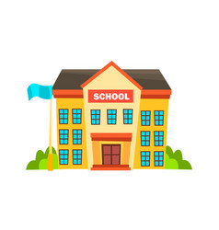
Are there any subjects you don’t enjoy as much? If so, why?

What do you like about school generally?

Is there anything about school you don’t like?

What are you most looking forward to about coming to Monkseaton High?

Is there anything you are worried about that we could help with?

Do you have any questions about Monkseaton?

