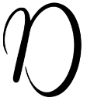
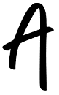
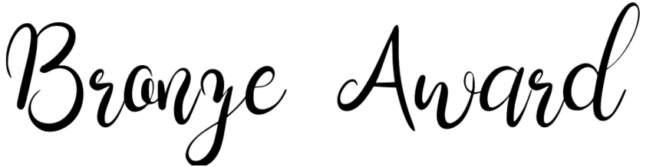
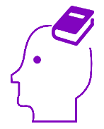
Did you know that regular reading has been proven to: reduce stress and anxiety; improve your vocabulary and comprehension; empower you to empathise with people; help you sleep better; fight symptoms of depression; improve your memory; enhance your imagination?

 | Challenge | Link | Write a short review here (25-100 words)
1 | Read the opening chapter of Sarah Crossan’s One | One
2 | Watch and listen to an author read from their work | Author videos
3 | Read about Climate Change | National Geographic
4 | Read about a breathing technique that helps us focus and which can help with anxiety. | Teen Breathe
5 | Read the opening chapter of We Are All Greta by Valentina Ginaella | We Are All Greta
6 | Read a news story from CBBC Newsround | CBBC Newsround
7 | Read a poem from the National Children’s Poetry Archive | The Children’s Poetry Archive
8 | Read an article from Wonk! magazine | Wonk!
9 | Read the opening chapter of Evernight by Ross McKenzie | Evernight
10 | Listen to at least the first couple of chapters of Harry Potter and the Philosopher’s Stone by J.K Rowling | Harry Potter and the Philosopher’s Stone

