We would love to find out about you
Insert Photo here!!

Name:

Current School:

Who do you live at home with?

Do you have any pets? What are they called? Any pictures?

What 3 words would you use to describe yourself?

What are your hobbies and interests?

Tell us a bit more…….
Are you a member of any clubs? E.G. a cadet squadron? A football team? If you play an instrument, what level do you play it to? If you enjoy reading, what sort of books do you enjoy?

What clubs are you interested in joining when you come to Monkseaton High? Have a look on the next page for some inspiration. Let us know if you would like to start up a new club.

Extra-Curricular Activities
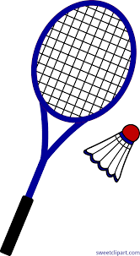
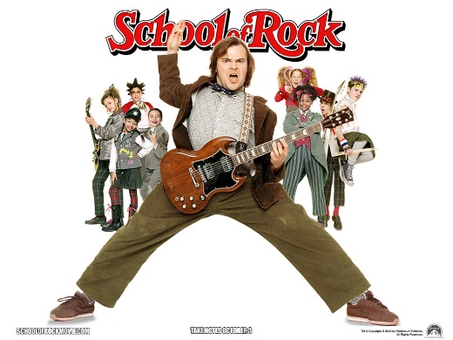

And loads more…..

