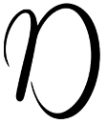
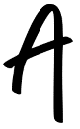
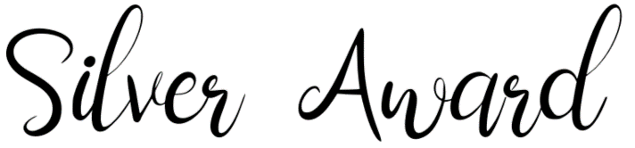
You may need to press the CTRL button as you click on a link to make it open.
 | Challenge | Link | Write a short review here (25-100 words)
1 | Listen to the first couple of chapters of the Ready Player One audiobook by Ernest Cline | Ready Player One
2 | Read the extract from Big Ideas for Young Thinkers by Jamia Wilson | Big Ideas for Young Thinkers
3 | Read the opening of Punching the Air by Ibi Zoboi and Yusef Salaam | Punching the Air
4 | Read the opening of Throne of Glass by Sarah J Maas | Throne of Glass
5 | Read The Crossover by Kwame Alexander | The Crossover
6 | Read Kay’s Anatomy by Adam Kay | Kay’s Anatomy
7 | Read at least the first chapter of Michael Grant’s Gone | Gone
8 | Listen to at least the first couple of chapters of Star Wars: Tales of the Jedi | Star Wars: Tales of the Jedi
9 | Read the extract from Skink No Surrender by Carl Hiaasen | Skink No Surrender
10 | Choose a report to read from BBC Sport | BBC Sport
11 | Read the opening of Dreadmarrow Thief by Margory Kaptanoglu | Dreadmarrow Thief
12 | Read the sample from Whispers in the Code by Stephanie and Isaac Flint | Whispers in the Code
13 | Listen to at least the first couple of chapters of The Knife Of Never Letting Go by Patrick Ness | The Knife of Never Letting Go
14 | Read the script for the first episode of the TV show Stranger Things by The Duffer Brothers | Stranger Things
15 | Read this article about the role seaweed might play in fighting climate change. | National Geographic  (create a free account)

